Explain the following questions in two simple sentences

- What is the use of the git add command?
The “git add” command is used to stage changes (new or modified files) in your working directory before committing them. It prepares the files to be included in the next commit.

- Write the command to create a branch “feature-group”.
git branch feature-group

- What is a pull request? Write the steps involved in creating a pull request.
A pull request lets you tell others about changes you've pushed to a branch in a GitHub repository so they can review and merge it.
Steps: Push changes → Go to GitHub → Click "Compare & pull request" → Add title and description → Click "Create pull request".

- How do you add collaborators?
Go to your GitHub repository → Click on "Settings" → "Collaborators" → Add their GitHub username or email → Click "Add collaborator".
They will receive an invite, which they need to accept to collaborate.

- What is the command used to commit our changes in github repo?
git commit -m "commit message"

- Create a github account and repository to save all your assignment tasks. Example repository name: rg-assignments

- Create a branch called feature-java(you can use it later to push all your java related tasks to this branch)
git branch feature-java

- Install IntelliJ IDE. Create a simple java project displaying “Hello World!!”and share the screenshot. 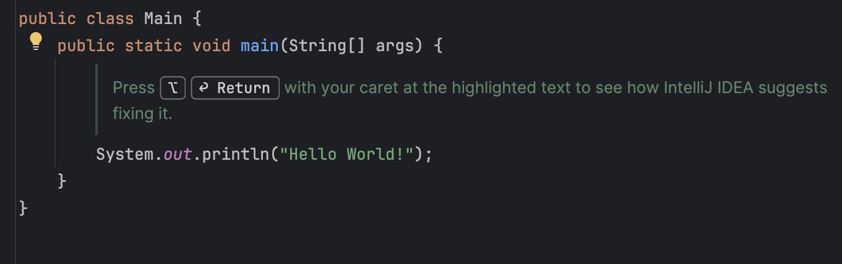

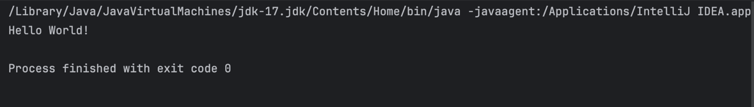

- In IntelliJ IDE, explore the shortcut keys for the following
  - To run the project : Shift + F10
  - To select a line : Home -> Shift + End
  - To comment/uncomment a line : Ctrl + /
  - To delete a line : Ctrl + Y

